**ASSESSMENT FOR**

**ITICOR0021A - Apply Occupational Health and Safety Procedures**

**ITICOR0231A - Operate A Personal Computer**

**ITINET1111A - Operate Peripherals Devices**

**ASSESSMENT – Research**

**TOPIC (GENERAL):** Apply Occupational Health and Safety Procedures

**TASK:** Identify Types of Safety Equipment for an Information and

Communication Industry

The principle of Occupational Health and Safety is that employers must provide a safe and

healthy environment for their employees. Prepare in Microsoft Word a document to show types

of safety signs and equipment used within an Information and Communication workplace.

1. Complete the task by creating a document in Microsoft Word to display the following safety equipment and signs below.

**Safety Equipment**

* Fire Extinguishers
* Fire Alarms
* Smoke Detectors
* Burglar Alarms
* Non-Skid Mats
* Door Chains
* Electronic Locks

**Safety Signs**

* No food or drink
* No smoking
* No entry authorized personnel only
* Exit
* No Running
* Keep work area tidy
* Shut down computer after use
* Do not overload electrical sockets
* Surf safely
* Electrical Hazard
* Slippery Surface
* First Aid
* Emergency Assembly Point
* Social Distancin

1. Provide a picture of each safety equipment and safety signs. Each picture should be appropriately place on the page.
2. State the use of each safety equipment and safety signs.

**The following checklist will be used to assess this assignment.**

**Points will be assigned with the following values:**

**The total score will be 50 marks. A total of 23 marks for Content, 4 marks for Design and Layout and 23 marks for Graphics.**

**You must obtain at least 30 out of 50 (60%) to be deemed competent. If you score less, you will be deemed not yet competent and will have to repeat the assignment.**

|  |  |  |  |  |  |  |  |  |  |  |  |  |  |  |  |  |  |  |  |  |  |  |  |  |  |  |  |  |  |  |  |  |  |  |  |  |  |  |  |  |  |  |  |  |  |  |  |  |  |  |  |  |  |  |  |  |  |  |  |  |  |  |  |  |  |
| --- | --- | --- | --- | --- | --- | --- | --- | --- | --- | --- | --- | --- | --- | --- | --- | --- | --- | --- | --- | --- | --- | --- | --- | --- | --- | --- | --- | --- | --- | --- | --- | --- | --- | --- | --- | --- | --- | --- | --- | --- | --- | --- | --- | --- | --- | --- | --- | --- | --- | --- | --- | --- | --- | --- | --- | --- | --- | --- | --- | --- | --- | --- | --- | --- | --- |
| **EVALUATION CHECKLIST**   |  |  |  |  | | --- | --- | --- | --- | | **Title: Safety Equipment Used Within an Information and Communication Workplace** | | | | | **Criteria** | **Allotted Grade** | **Grade obtained** | ***Notes****(how this could be improved?)* | | **CONTENT** |  |  |  | | Function of each safety equipment | **7** |  | | Function of each safety sign | 16 |  | | **TOTAL** | **23** |  | |  | | | | **DESIGN AND LAYOUT** |  |  |  | | Alignment of picture and text on page | **1** |  | | Name of each equipment and sign is clearly stated | **1** |  | | Appropriate use of fonts and color usage | **1** |  | | Head page 1 appropriately including student name | **1** |  | | **TOTAL** | **4** |  | |  | | | | **GRAPHICS** |  |  |  | | Appropriate clipart or picture for each safety equipment | **7** |  | | Appropriate clipart or picture for each safety sign | 16 |  | | **TOTAL** | **23** |  | | **Overall Total** | **50** |  |  | |  |  |

**Candidate Signature:** ______________________________ **Date:** ________________

**Assessor Signature:** ______________________________ **Date:** ________________

**Internal Verifier Signature:** ___________________________ **Date:** ________________

*(Only if task is an internal verficiatio*

[A fire extinguisher is a **handheld active fire protection device.**](https://en.wikipedia.org/wiki/Fire_extinguisher) It is used to extinguish or control small fires, often in emergencies

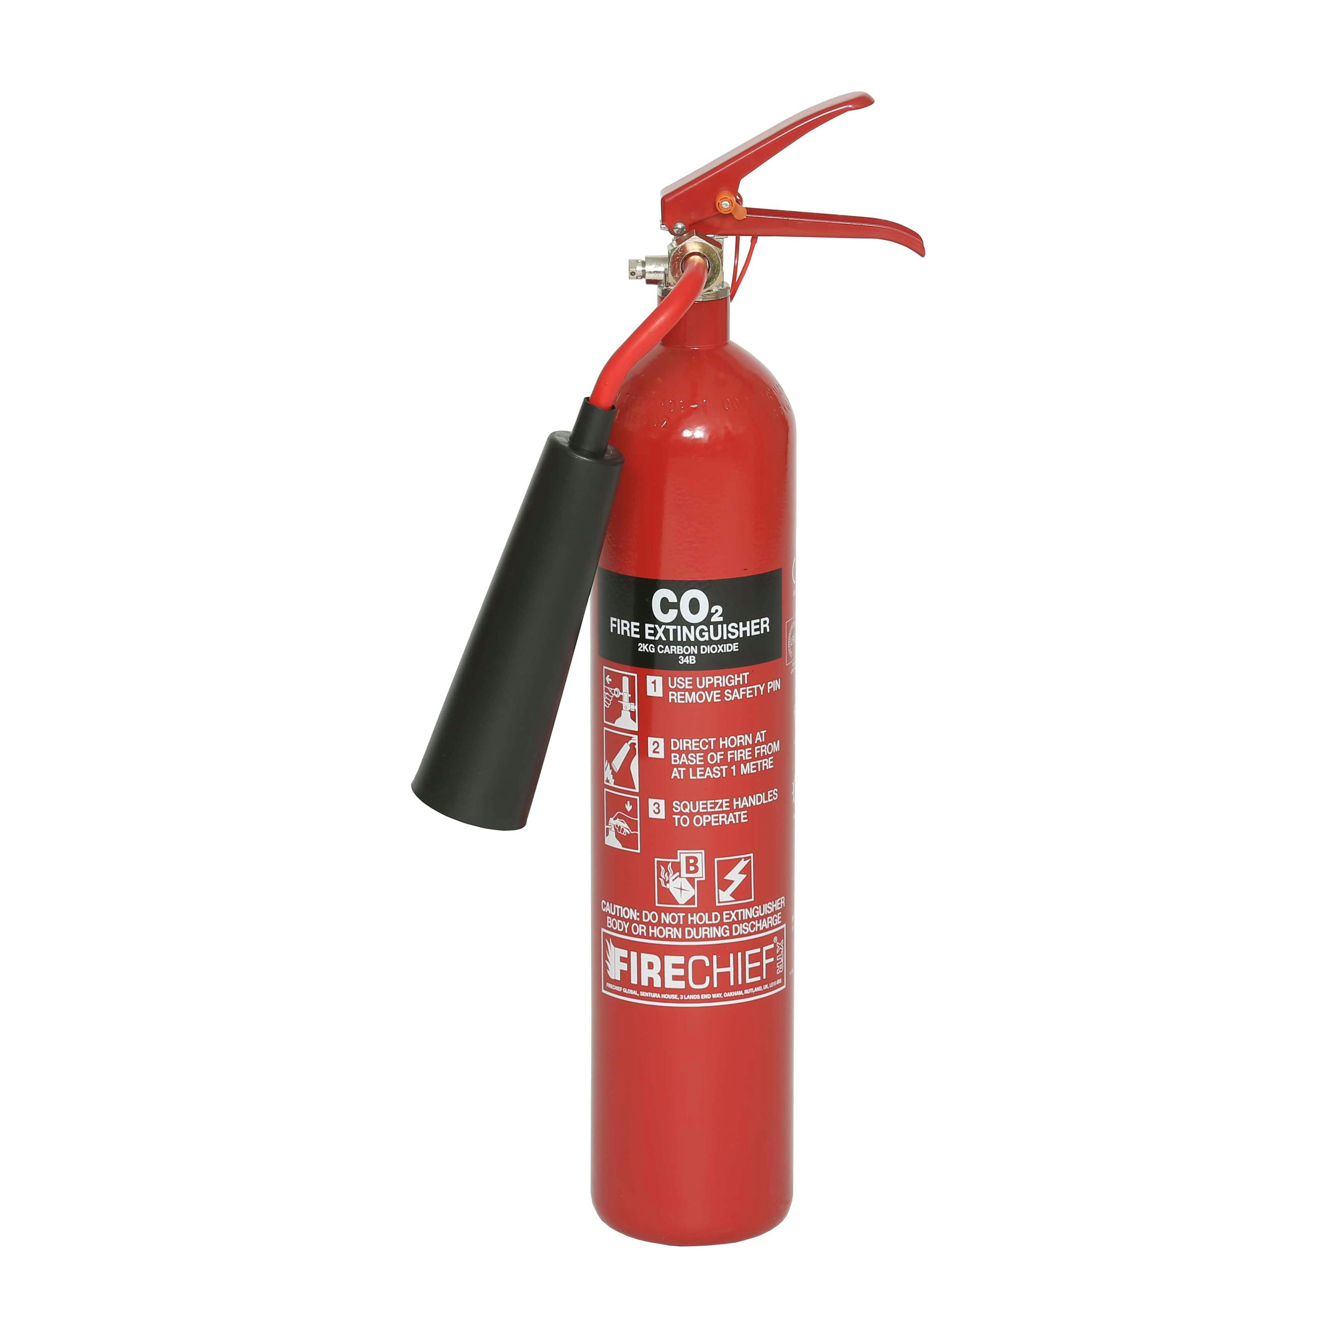

A fire alarm system is **a building system designed to detect,** alert **occupants,** and alert emergency forces of the presence of fire, smoke, carbon monoxide, or other fire-related emergencies. Fire alarm systems are required in most commercial buildings.

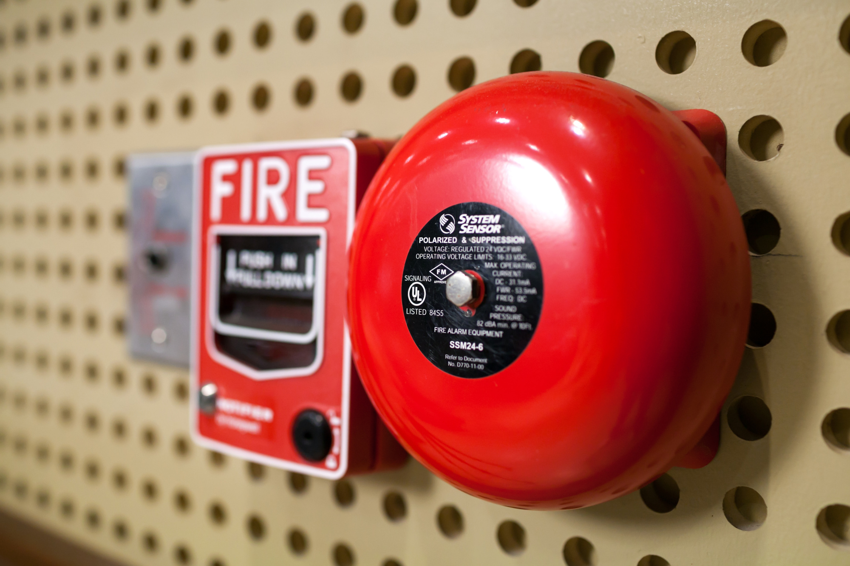

A smoke detector is **a device that senses smoke, typically** as **an indicator of fire.**

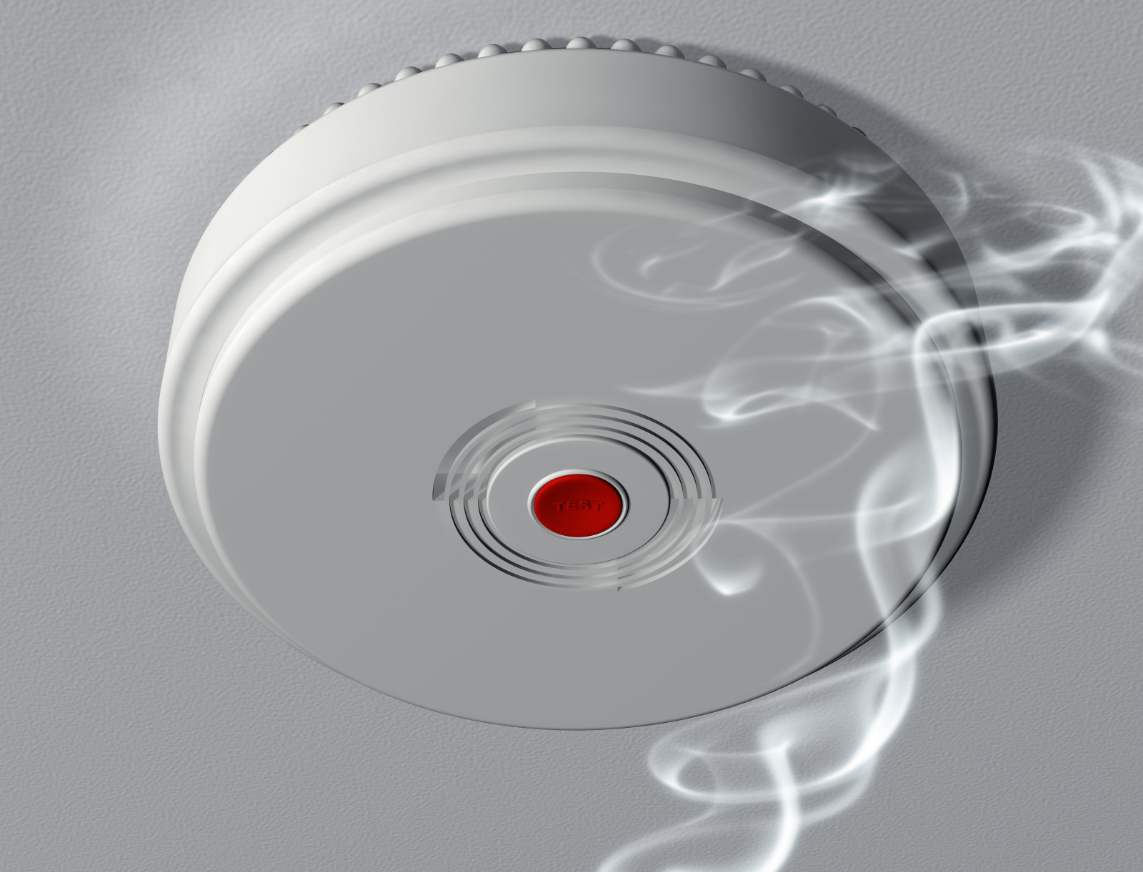

A burglar alarm system consists of a series of electrical components that are connected to a property.

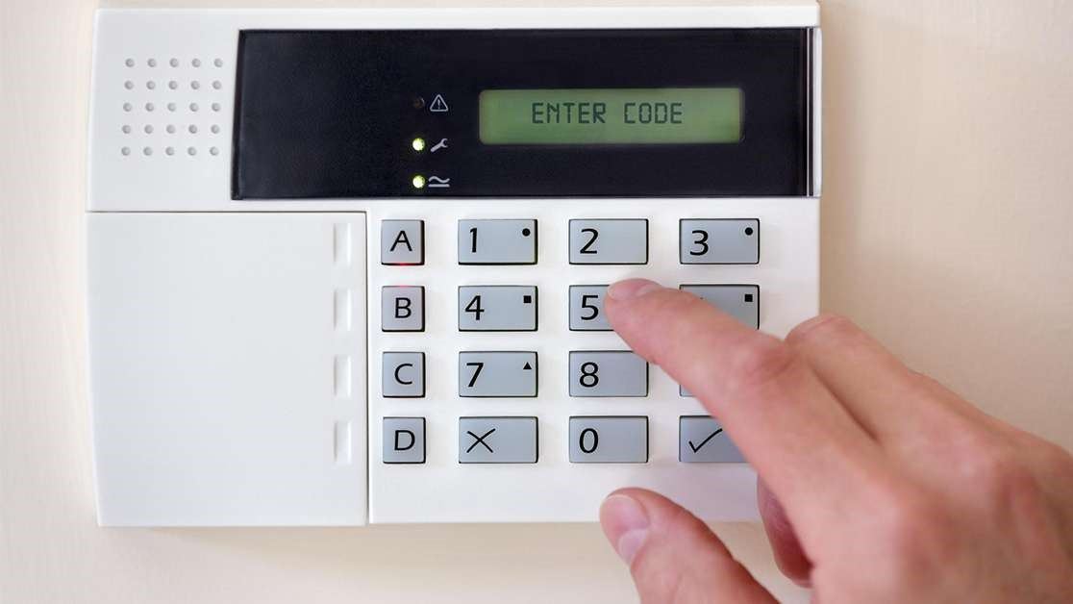

A door chain is a restriction that has been designed to prevent distraction burglary and stop an intruder from entering your home when you open your front door

An **electronic lock** is a [locking device](https://en.wikipedia.org/wiki/Lock_(security_device)) which operates by means of electric current. Electric locks are sometimes stand-alone with an electronic control assembly mounted directly to the lock.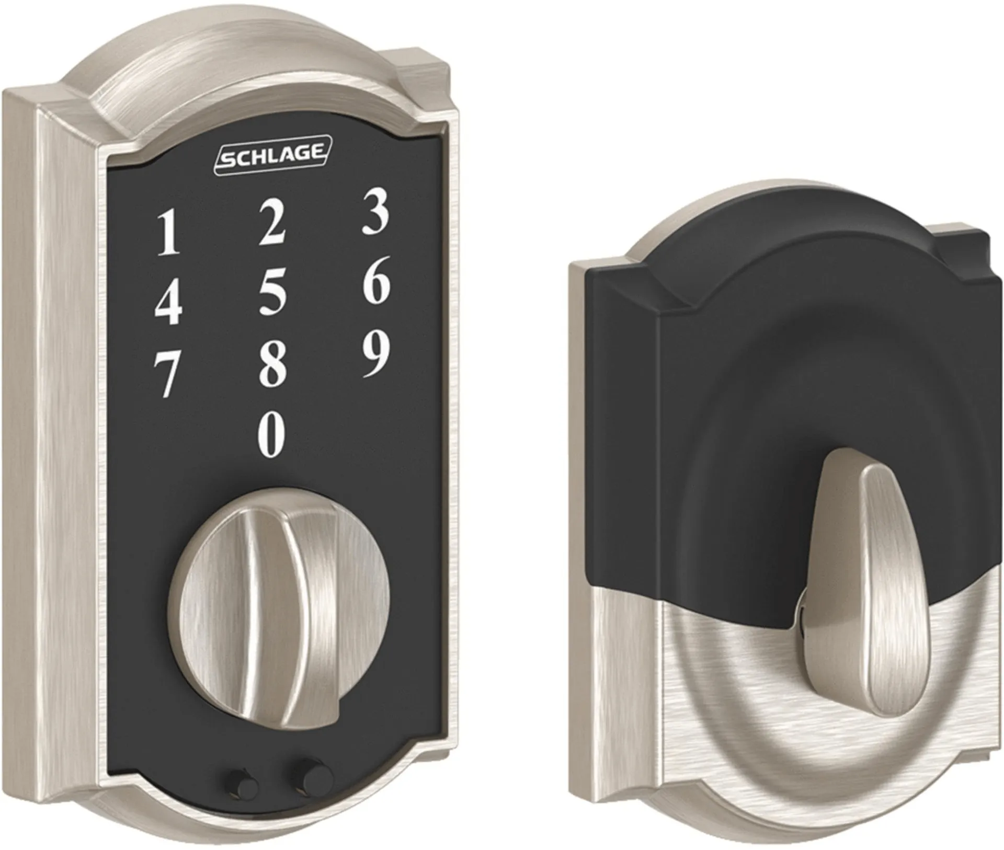

. Eating or drinking in the lab can, first and foremost, increase your risk of hazard

Materials.

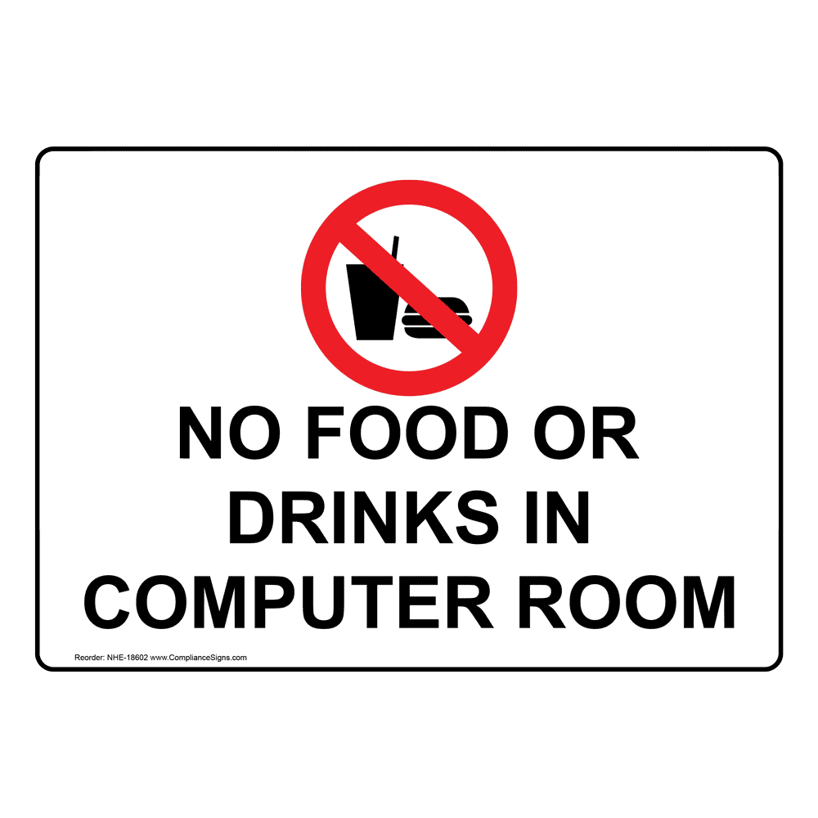

Smoking in a laboratory is a dangerous and ill-advised practice that can pose significant risks to the laboratory, its staff, and important research & experiments. Not only is it a fire hazard & contamination risk, but it can also have serious health consequences for everyone involved.

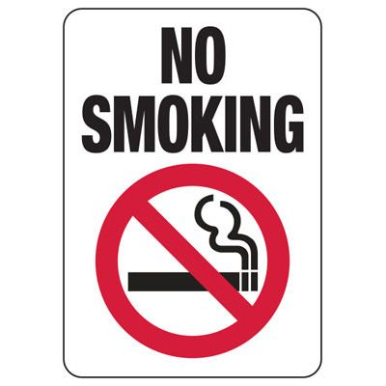

Smoking in a laboratory is a dangerous and ill-advised practice that can pose significant risks to the laboratory, its staff, and important research & experiments. Not only is it a fire hazard & contamination risk, but it can also have serious health consequences for everyone involved.

Authorized personnel signs and "do not enter" signs mark restricted areas where only those with permission are allowed entry

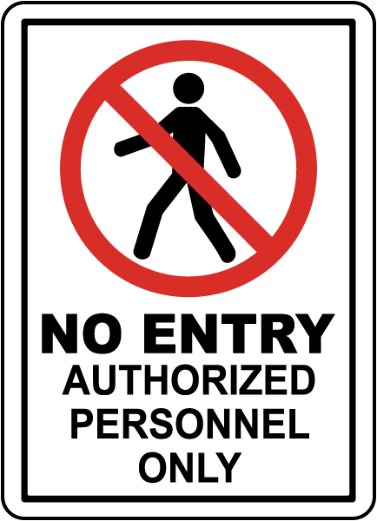

To exit is to go out of or leave a place. When an actor exits, he moves off the stage and out of sight of the audience.

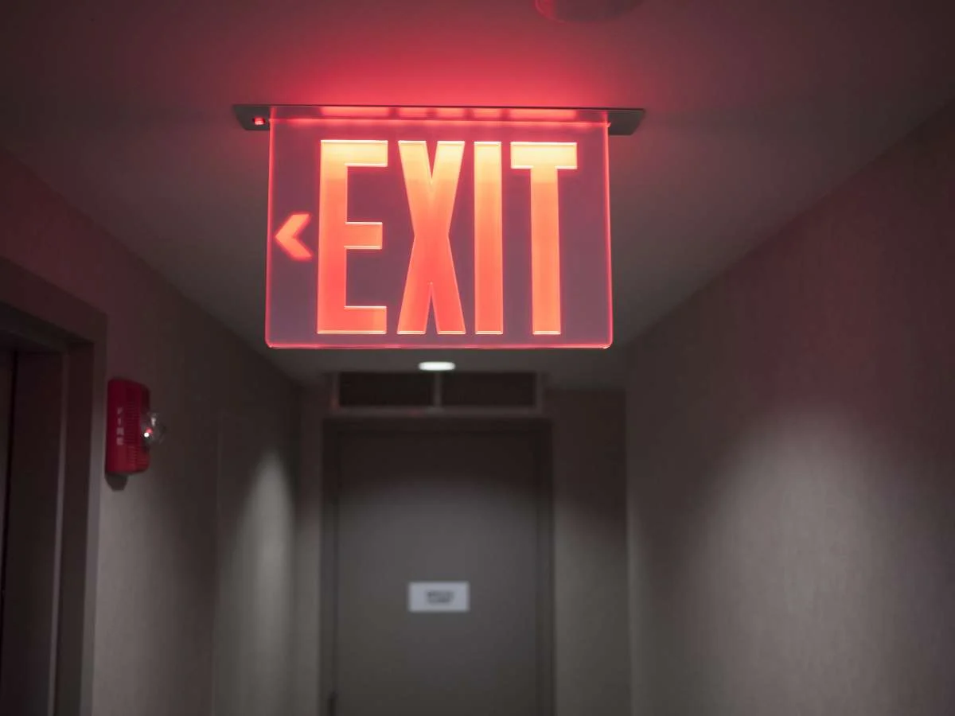

To exit is to go out of or leave a place.

Cabinets and shelves should be secured to the wall to prevent tipping. Try to store extra, unused, or spare equipment out of your main work area, if possible. If there is no available storage room, you could have an assigned storage area in less-used part of your lab.

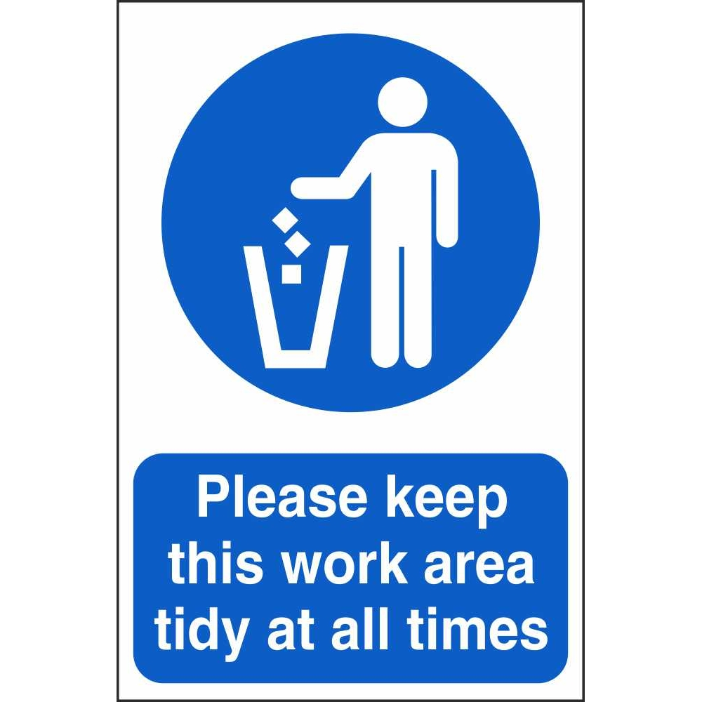

First aid is the first and immediate assistance given to any person with either a minor or serious illness or injury,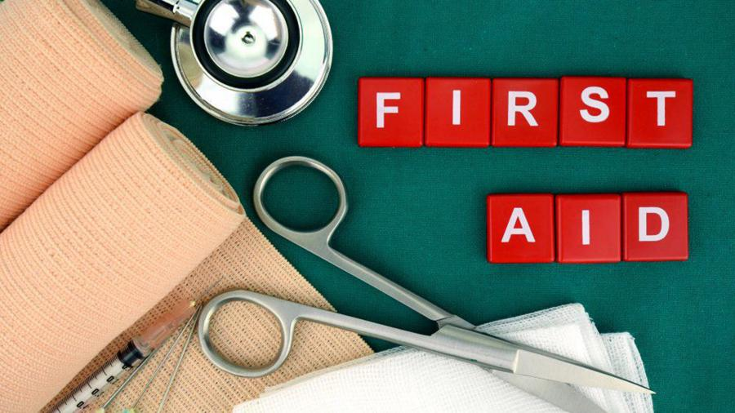

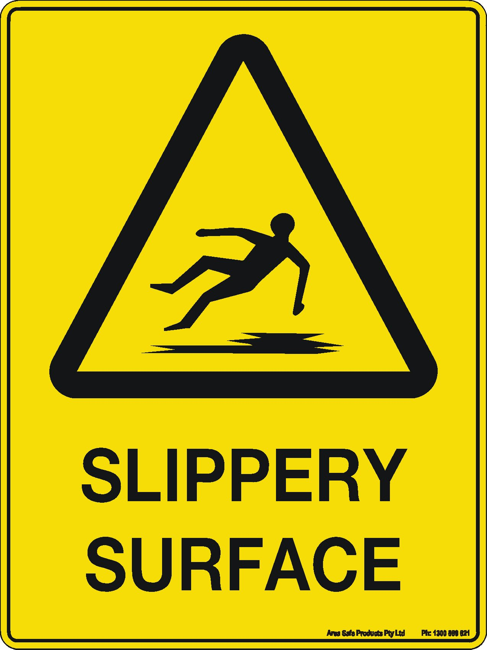

Something that is slippery is smooth, wet, or oily and is therefore difficult to walk on or to hold.

Electrical hazards refer to the potential dangers and risks that are associated with electrical systems. 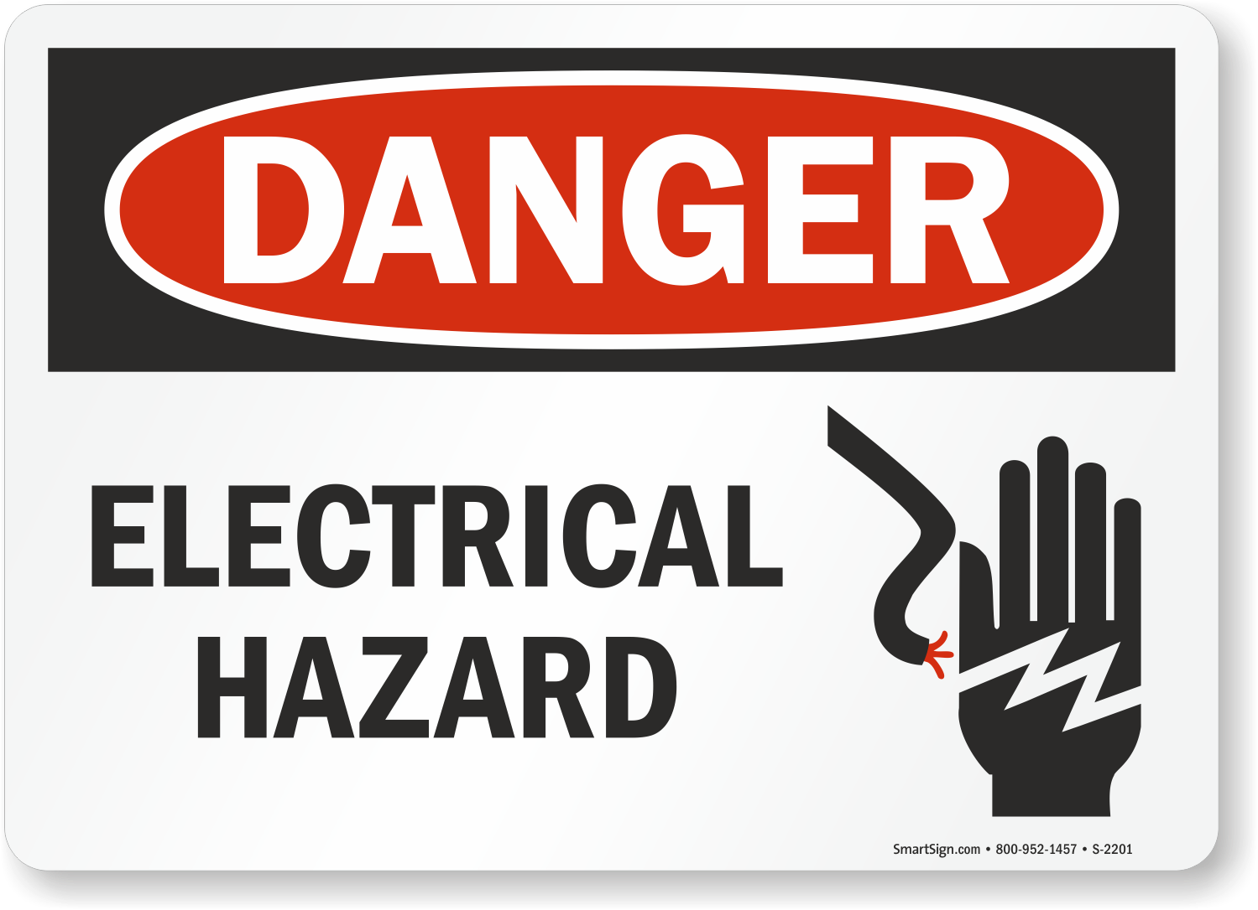

Social distancing is a public health practice that aims to prevent sick people from coming in close contact with healthy people in order to reduce opportunities for disease transmission